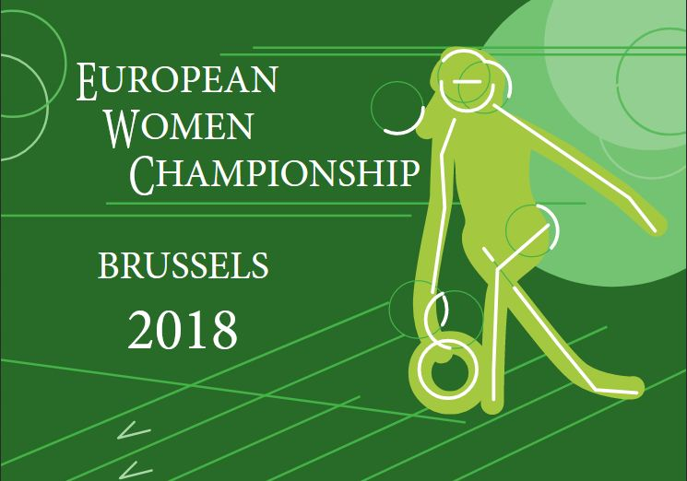

THE BULLETIN

6-17 June 2018 in Brussels, Belgium

 | 

Brussels, 11 December 2017

European Women Championships 2018: The Bulletin

It is a pleasure for Belgian Bowling Federation and bowling centre Bowling Stones to present The Bulletin for The European Women Championships 2018 (EWC 2018) to all federations affiliated to the European Tenpin Bowling Federation.
The championships will be hosted in co-operation between 4 main partners; the European Tenpin Bowling Federation, The Belgian Tenpin Bowling Federation, Bowling Stones Bowling Centre and the Cities of Wemmel and Brussels. Our hotel partners are Ibis Expo en Gosset hotel.
This bulletin will be the only bulletin circulated before the EWC 2018.

The content of the Bulletin, all future amendments and all confirmations etc., is and will be reflected at the official championship website: www.ewc2018.be.

Please pay attention to the deadlines presented in this bulletin, Chapter 9.

The deadline for the entry form and the hotel form is 23.02.2018. Your team cannot enter the championship, if you do not meet this very important deadline.

Please address all forms, questions and requests to the Host Tournament Manager of the EWC 2018, Marc Beaufays. Email address: secretary@bowling.be /Phone: +32 2 732 4808.

We are looking forward to serve you in the coming months up till and during the championships, and of course to welcome you to Brussels in June next year!

Kind Regards
Marc Beaufays
Host Tournament Manager
Bulletin content

- The schedule

- Hotels

- The Cities of Wemmel and Brussels

- Bowling Stones Bowling Centre

- Fees and payments

- Equipment

- Various information
    - National Committee
    - International Committee
    - Programme book
    - Entry to the centre
    - Bus services
    - Result services
    - Press facilities
    - Lane assignments
    - Flags and national anthems
    - Doping tests

- Travel and visa information

- Forms and deadlines
A: Entry Form
B: Hotel Form
C: Room list for
D: Arrival and departure
E: List of athletes and officials in the team
F: List of guests
G: Press Accreditation
H: Ball Registration Form

1. The schedule

The schedule is prepared for a maximum of 160 athletes.
No major changes in the schedule are expected.

In each of the 3 squads scheduled for the official practice, there will be 10 shifts of 9 minutes, in total 1.5 hour per team.

In each of the events: Singles, Doubles, Trios and Team, there will only be one team per federation in each squad.

Unofficial practice
The centre is open for unofficial practice by payment as follows:
**On Tuesday 5 June 2018 between 14.00 and 20.00
**On Wednesday 6 June 2018 between 10.00 and 20.00

**The price for one lane/hour is € 20.

Lanes for unofficial practice can be booked by contacting BTBF at the email address:
secretary@bowling.be.

We expect the lanes to be dressed with various issues of the pattern, which might be further changed by the technical officials of the championships before the managers meeting.

Weekday | Date | From | To | Activity
Tuesday | 05.06.2018 | - | - | Ball Registration
Tuesday | 05.06.2018 | 14.00 | 20.00 | Unofficial practice

Weekday | Date | From | To | Activity
Wednesday | 06.06.2018 | - | - | Last day of team arrivals
Wednesday | 06.06.2018 | - | - | Ball Registration
Wednesday | 06.06.2018 | 10.00 | 20.00 | Unofficial practice

Weekday | Date | From | To | Activity
Thursday | 07.06.2018 | 09.00 | 18.00 | Ball Registration
Thursday | 07.06.2018 | 08.00 | 09.00 | Lane Maintenance
Thursday | 07.06.2018 | 09.00 | 10.00 | Team Managers meeting in the centre
Thursday | 07.06.2018 | 10.30 | 12.00 | Official Practice Squad 1
Thursday | 07.06.2018 | 12.00 | 13.00 | Lane Maintenance
Thursday | 07.06.2018 | 13.00 | 14.30 | Official Practice Squad 2
Thursday | 07.06.2018 | 14.30 | 15.30 | Lane Maintenance
Thursday | 07.06.2018 | 15.30 | 17.00 | Official Practice Squad 3
Thursday | 07.06.2018 | 17.00 | 18.00 | Break and line up
Thursday | 07.06.2018 | 18.00 | 18.30 | Opening Ceremony in the centre

Weekday | Date | From | To | Activity
Friday | 08.06.2018 | 08.00 | 09.00 | Lane Maintenance
Friday | 08.06.2018 | 09.00 | 12.45 | Singles Squad 1
Friday | 08.06.2018 | 12.45 | 13.45 | Lane Maintenance
Friday | 08.06.2018 | 13.45 | 17.30 | Singles Squad 2

Weekday | Date | From | To | Activity
Saturday | 09.06.2018 | 09.00 | 10.00 | Lane Maintenance
Saturday | 09.06.2018 | 10.00 | 13.45 | Singles Squad 3
Saturday | 09.06.2018 | 13.45 | 15.00 | Break and Lane Maintenance
Saturday | 09.06.2018 | 15.00 | 15.45 | Singles Semi Finals
Saturday | 09.06.2018 | 15.45 | 16.30 | Singles Final
Saturday | 09.06.2018 | 16.30 | 17.00 | Medal Ceremony, Singles

Weekday | Date | From | To | Activity
Sunday | 10.06.2018 | 08.00 | 09.00 | Lane Maintenance
Sunday | 10.06.2018 | 09.00 | 12.45 | Doubles Squad 1
Sunday | 10.06.2018 | 12.45 | 13.45 | Lane Maintenance
Sunday | 10.06.2018 | 13.45 | 17.30 | Doubles Squad 2

Weekday | Date | From | To | Activity
Monday | 11.06.2018 | 09.00 | 10.00 | Lane Maintenance
Monday | 11.06.2018 | 10.00 | 13.45 | Doubles Squad 3
Monday | 11.06.2018 | 13.45 | 15.00 | Break and Lane Maintenance
Monday | 11.06.2018 | 15.00 | 15.45 | Doubles Semi Finals
Monday | 11.06.2018 | 15.45 | 16.30 | Doubles Final
Monday | 11.06.2018 | 16.30 | 17.00 | Medal Ceremony, Doubles

Weekday | Date | From | To | Activity
Tuesday | 12.06.2018 | 09.00 | 10.00 | Lane Maintenance
Tuesday | 12.06.2018 | 10.00 | 12.45 | Trios Squad 1
Tuesday | 12.06.2018 | 12.45 | 13.45 | Special Olympics
Tuesday | 12.06.2018 | 14.00 | 15.00 | Lane Maintenance
Tuesday | 12.06.2018 | 15.00 | 17.45 | Trios Squad 2

Weekday | Date | From | To | Activity
Wednesday | 13.06.2018 | 08.00 | 09.00 | Lane Maintenance
Wednesday | 13.06.2018 | 09.00 | 11.45 | Trios Squad 2
Wednesday | 13.06.2018 | 11.45 | 12.45 | Lane Maintenance
Wednesday | 13.06.2018 | 12.45 | 15.30 | Trios Squad 1
Wednesday | 13.06.2018 | 15.30 | 16.30 | Break and Lane Maintenance
Wednesday | 13.06.2018 | 16.30 | 17.30 | Trios Semi Finals
Wednesday | 13.06.2018 | 17.30 | 18.30 | Trios Final
Wednesday | 13.06.2018 | 18.30 | 19.00 | Medal Ceremony, Trios

Weekday | Date | From | To | Activity
Thursday | 14.06.2018 | 09.00 | 10.00 | Lane maintenance
Thursday | 14.06.2018 | 10.00 | 14.30 | Team Squad A

Weekday | Date | From | To | Activity
Friday | 15.06.2018 | 08.00 | 09.00 | Lane maintenance
Friday | 15.06.2018 | 09.00 | 13.30 | Team Squad B
Friday | 15.06.2018 | 13.30 | 14.30 | Break and Lane Maintenance
Friday | 15.06.2018 | 14.30 | 16.00 | Team Semi Finals
Friday | 15.06.2018 | 16.00 | 17.30 | Team Final
Friday | 15.06.2018 | 17.30 | 18.30 | Medal Ceremonies Team & All Event

Weekday | Date | From | To | Activity
Saturday | 16.06.2018 | 08.00 | 09.00 | Lane Maintenance
Saturday | 16.06.2018 | 09.00 | 10.15 | Masters Step 1 (8 matches)
Saturday | 16.06.2018 | 10.15 | 11.30 | Masters Step 2 (8 matches)
Saturday | 16.06.2018 | 11.30 | 12.30 | Break and Lane Maintenance
Saturday | 16.06.2018 | 12.30 | 13.45 | Masters Step 3 (4 matches)
Saturday | 16.06.2018 | 13.45 | 15.00 | Masters Step 4 (2 matches)
Saturday | 16.06.2018 | 15.00 | 16.15 | Masters Final
Saturday | 16.06.2018 | 16.30 | 17.00 | Medal Ceremony Masters
Saturday | 16.06.2018 | 19.30 | - | Farewell Banquet in bowlingcenter

Weekday | Date | From | To | Activity
Sunday | 17.06.2018 | - | - | Departures

2. Hotels

Gosset Hotel
Alfons Gossetlaan 52
1702 Dilbeek

Ibis hotel
Romeinse steenweg 572
1853 Brussel

We are happy to announce our partnership with these hotels

The hotels are very comfortable situated in relation to the centre (10 minutes’ drive) and the airport (15 minutes’ drive).

The room rates are as follows:

Gosset Hotel  Single rooms: | 110 €
Double rooms: | 120 €

Ibis Hotel
Single rooms: 115 €
Double rooms 125 €

These very favourable rates include:
- Modern but small hotel rooms
- All national taxes
- A breakfast buffet
- Free Wi-Fi at the entire hotel

Booking, payment and cancellation instructions for the hotels

Please use Form B send them filled in to secretary@bowling.be

Your booking is not finally confirmed until all rooms are fully paid.

**In case of room cancellations in the period starting with Saturday 10 March and ending with Sunday 22 April 2018, two nights will be charged for each room cancelled.

3. The City of Brussels

Apart from being the centre of European politics, Brussels has a fascinating and old history that dates back to the 11th century when it began as a small dukedom the size of the current downtown area. In 1830 Belgium became independent and Brussels became the capital of Belgium under a new king and parliament. Find out more about the interesting facts of Belgium through a mixture of facts, history, cultural traditions and political infrastructure. | 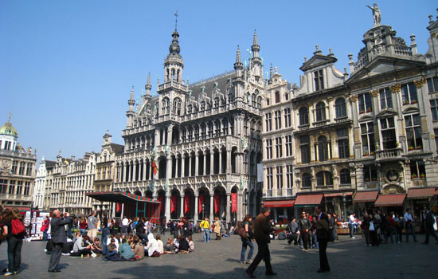
Quick facts about Brussels
Brussels region is made up of 19 separate communes; the City of Brussels is one of these communes has about 150,000 inhabitants and dates back to the original city built in the 13th century. Some fun facts about Brussels include the fact that on last count there are 249 butchers, 874 hairdressers and 647 pharmacies. This can be noticed almost immediately when you walk down the streets, you will see at least 1 hairdresser and 1 or 2 pharmacies, which are marked by giant neon green cross signs. Brussels is one of the most international cities in the world. 27% of the population is made up of foreigners, not including those who have taken Belgian citizenship. In following with its status as the Capital of Europe (the seat of the European Union), Brussels is the location for 40,000 EU employees, 4,000 NATO employees and hosts about 300 permanent representations: lobby groups, embassies and press corporations.
Brussels has a temperate climate with four seasons spanning the whole year. Temperatures are relatively mild during the whole year with the average low at 1°C in winter and only 23°C in summer. Winds tend to be slightly stronger in winter but the most constant weather pattern would be rainfall. Snow is possible but doesn’t occur very often.
Language
It is an interesting fact about Belgium that Belgians do not share one common language. There are three official languages in Belgium: French, Dutch (Flemish) and German. Language is such an important part of the political and cultural infrastructure that the country created an official language border between the north and south and also a third region which is Brussels. In Brussels people mostly speak French but it is official bilingual so all public signage and documents are in both languages.

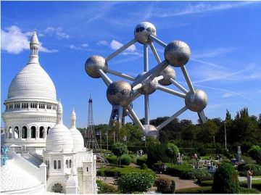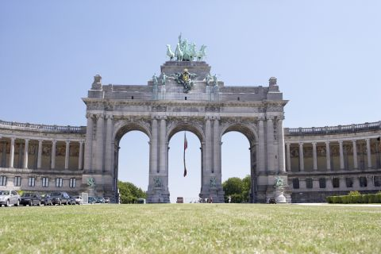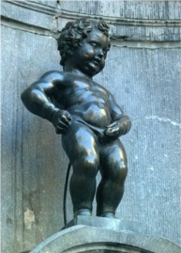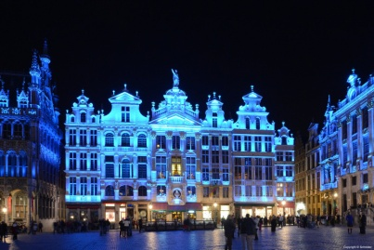
4. Bowling Stones Bowling Centre

About the centre
Steenweg op Brussel 397, 1780 Wemmel, Belgium / www.bowlingstones.be

The bowling centre is situated next to the highway about 10 minutes’ drive from the hotels.

The bowling centre is divided in two floors, with lanes, reception, dressing rooms, restaurant and café in the basement; administration, press room and meeting rooms at the first floor.

The restaurant and the café will be open to serve all delegates and guests during the EWC 2018.

In the meeting rooms at the first floor, we will install the press room and a room for the championship technicians.

Technical specifications:

Number of lanes: | 36 AMF lanes
Lane approach: | SPL AMF approaches
Lane surface: | Ultra lite lane surfaces
Pin decks: | A420 Qubica AMF pin decks
Pin setters: | AMF90Xli pin setters
Pins: | Amflite II pins will be used
Dressing equipment: | Kegel
Lane conditioners: | Kegel
Lane cleaner: | Kegel
Score system: | Qubica scoring system

The length of the oil pattern will be published a few months prior to the championships.

5. Fees and payments

All fees are expressed in Euros.

Entry fee
The EWC 2018 entry fee is 280 €. The fee to be paid to ETBF is included.

This fee is applicable for all delegations, including athletes, coaches, managers, head of delegations and other officials connected to each team.

Guest fee
The EWC 2018 fee for official guests is 140 €. This fee includes entrance to the centre, the farewell dinner and transport from the airport to the hotels and to the bowling centre.

Farewell Dinner fee
The EMC 2018 farewell dinner fee is 60 €.

This fee is only for team supporters, not for the members of the delegations, who naturally are invited to the Farewell Dinner for free.

Hotel room rates
Please check chapter 3 for the room rates at the Gosset and Ibis hotels.

Bank transfer details
When we have received the number of persons in your championship delegation, the number of guests and your hotel booking, you will receive an invoice from us.

At the invoice you will find the necessary bank transfer information and the payment deadline.
Please remember to pay all bank fees both from the sending and the receiving bank.

6. Equipment

Inspection and selection
Each athlete can bring an unlimited amount of bowling balls to the championship venue.

As soon as possible after arrival you must, for each athlete, deliver a filled in issue of form H to the ETBF Technical Delegate.

The inspection is limited to eligibility of the ball as specified in the list of approved bowling balls, the serial number of each ball and a visual inspection with regard to damages etc.

Only bowling balls, that are included in the USBC Approved Bowling Ball list, can be used in competition. The official list of approved bowling balls is published on www.bowl.com.

Bowling balls manufactured prior to 1991 cannot be found on the USBC Approved Bowling Ball list.

Immediately following the conclusion of the official practice session, the coach of the team must modify Form I for all his team members, so each form includes only a maximum of 6 bowling balls to be used during competition.

All bowling balls, not selected to be used during competition, must, with no hesitation, be removed from the bowling centre and brought back to the hotel. The ball store room will occasionally be examined for non-registered bowling balls, which will be declared in use, if found.

No replacements or additions of bowling balls will be allowed once the first event has started, and no modifications of a bowling ball shall be permitted, apart from the altering of the surface according to the rules specified in the ETBF Constitution. In very special circumstances, the Championship Committee may allow a replacement of a registered bowling ball.

Random checks of the identity of the bowling balls used in competition will be performed during the squads at the discretion of the Championship Committee. The penalty for violation of the rule is disqualification and all scores null and void.

A room, connected to the 1st floor of the bowling centre, will be used to store the equipment. There will be an easy and short distance from this room.

How to pack your bowling balls
Please separate bowling bags and packages with balls and equipment from your private luggage.

Each bowling bag and each package with balls must be provided with a sticker or a label with the full name of the athletes and his/her federation. Please do not pack bowling balls from more than one athlete in the same bag / package.

By your arrival to the airport in Brussels, we will separate bowling bags / packages from the private luggage of the athletes.

7. Various information

National Committe

If you have any questions regarding the EMC 2018, please do not hesitate to contact the organizing committee.

Here are the names and the tasks of the members of the organizing committee:
Marc Beaufays | Host Tournament Manager
Sonja Bruyland – Philippe Michel | Reception - Ceremonies
Veronique Perniaux – Mitch Brams | Financial Management
Geoffrey Frederickx | Website, Internet and IT Services
Tim Mertes | Press – Local information
Guy Pellegroms | Logistics
Mieke Rasson | Bowling Centre Management
Peter De Ceuninck | Technical matters
Johan Peremans | Referees

The address of the organizing committee is as follows:

BBSF-FSBB
Rue Colonel Bourg 123-125
1140 Evere
Belgium
Phone: +32.2.732 48 08
Fax: +32.2.732.49.92
Email: secretary@bowling.be

International Committees
The Jury of Appeal will be announced latest at the Team Managers meeting.

The Championship Committee consists of:
Kim Thorsgaard Jensen, ETBF Championship Director
Marios Nicolaides, ETBF Technical Delegate
Marc Beaufays, Host Tournament Manager

Website
The official website of the EWC 2018 is www.ewc2018.be. It will be updated continuously with all information concerning the championships.
Information will also be provided via Facebook.
The website will be compatible with smartphones and tablets.

Programme book
The welcome statements from notabilities, all delegations presented, various statistics and advertisements will not be printed, but made available at the website for downloads, for applets etc.

Entry to the centre
Each athlete, official, press representative, registered guest and member of the local organisation will receive an entry card, of which there will be various categories, some with certain restrictions depending on duties.

There will be an entrance fee of 10 € per day to the bowling centre for spectators during the EWC 2018.

Bus services
All delegations, not using other means of transportation and accommodated at the Gosset or Ibis hotels, will be met in Brussels International Airport. A similar service will be provided upon departure.

An hourly shuttle service, hotel-centre-hotel and centre-hotel-centre, will be provided for all athletes, coaches, officials and registered guests staying at the championship hotels.

In addition there will be mini busses available for various special situations.

Any bus and transport service is, in general, only available for those staying at the Gosset and Ibis hotels.

Result services
Results and standings will promptly be published at www.ewc2018.be and in the centre at various monitors and screens.

Press facilities
One meeting room at the first floor will be used for press activities. We expect to be able to provide space and capacity for up till 12 press representatives in the room.

Access to the press room will be restricted and limited to accredited press officials only.

The line capacity will, however, during the EWC 2018 be very good for everybody attending, so wherever you are in the centre, you will have good working conditions.

Therefore, do only ask for an accreditation, if you are working with press-relations and frequently need access to a room, where you can work with your stories and photos in peace.

Lane assignments
All lane assignments will be decided by a squad-by-squad draw, done by the championship committee, while all attending federations have been through the registration procedure.

The first lane assignments are often published shortly after the Team Managers meeting.

Flags and national anthems
Do not bring any flags; they will be delivered by ETBF.

From the ETBF website, we will pick the national anthems we need during the championships. Therefore; do not bring your national anthems.

Doping tests
No international doping tests will be performed, but the Flemish government might decide to perform tests at any moment they want during the championships.

Please inform your athletes, that they always must be prepared to be tested upon request.

8. Travel and visa information

Arriving by car
Wemmel is a suburb of Brussels, the capital of Europe. The centre is situated next to the high way E19 exit 9 (Jette).

Arriving by plane
There are numerous daily flights to Brussels International Airport.

Our airport pick-up and delivery service does only include planes landing in Brussels Central (Zaventem). There is no pick-up service from the airports in Charleroi, Antwerp and Ostend.

From the Airport in Brussels, there is less than 15 minutes’ drive to the Gosset and Ibis Expo hotels.

Special offer from Brussels Airlines
Brussels Airlines has put a special package together for the EWC 2018 delegations.

The offer concerns:
- Flights operated by Brussels Airlines
- European destinations
- Groups and individual travellers
- Return flight tickets on Class B-Flex

Rate:
There will be a fixed rate of 300 € per ticket, excluding airport taxes

Further details of the offer
- B-Flex on board service
- Free name change up to departure
- Free change of return date up to the last available seat
- Free luggage 1 x 23 kg
- Free sport equipment (two bowling bags (three balls) max 23 kg each)
- VIP services
- Premium check-in
- Security Fast lane access
- Lounge access
- Premium seating (middle seat free if possible)
- Food and newspapers

Contact info for the special Brussel Airlines offer
Please contact Thierry Vancalster
Phone: +32 22 005 279 / Email: thierry.vancalster@bcdme.com

Countries, where visas are necessary
We have checked a newly updated list from the Belgian Department of Foreign Affairs and found that visa is demanded for entrances for the following ETBF member federations:

Azerbaijan
Belarus
Kazakhstan
Russia
Turkey
Ukraine

In case of any doubt, we will recommend you to contact the Belgian embassy or consular in your country and ask for the demands and the application procedure.

Special invitations
In some occasions visas can be achieved without any special invitations from our side.

In other cases, special invitations and letters might be necessary to process the visa applications at the Belgian embassy or consular in your country. In these cases, please contact us in due time and also present any special content needed of the documents we must provide.

We will try to assist you with such invitation letters from case to case, but it is very important that you are contacting us in due time and not in the last minute.

Registration in Bowlingstones Bowling Centre
It is very important that each team manager turns up for a team registration in the centre soonest possible after the arrival. During the registration, we will validate the number of athletes, the data of each athlete, the passport for nationality validations and all payments.

As sooner all teams have gone through the registration, as earlier we can publish the lane assignments for the singles events.

9. Forms and deadlines

Attached to this bulletin are 8 forms related to the EWC 2018.

Meeting the deadlines mentioned is essential for our preparations, and a clear benefit for attending teams and the championships in general.

Form | Subject | Delivery deadline
Form A | Entry Form | Friday 23 February 2018
Form B | Hotel Form | Friday 23 February 2018
Form C | Room list | Friday 27 April 2018
Form D | Arrival and departure | Friday 27 April 2018
Form E | List of athletess and officials in the team | Friday 27 April 2018
Form F | List of guests | Friday 11 May 2018
Form G | Press Accreditation | Friday 2 June 2018
Form H | Ball Registration Form | Upon arrival

Form A: Entry Form
Please return this form even if you do not want to send a team to the EWC 2018.

Federation

Confirmation
We will send a team (Yes/No)

The delegation
Number of athletes in the team
Number of officials connected to the team

Contact information
Contact person for the team
Mobile
Email

Delivery information:
Final delivery deadline: Friday 23 February 2018
Send by email to the BTBF Office at: secretary@bowling.be

Form B: Hotel Form
Booking at this hotel includes free access to the hourly shuttle service hotel-centre-hotel

Federation

Hotel Gosset (Yes/No)
Ibis Hotel (Yes/No)
Using another accommodation (Yes/No)

Number of rooms | Room type (1/2) | Arrival date | Departure date

1 Single
2 Double

The hotels will not accept bookings. So send your bookings directly to the organization, not to the hotel.

All booked room-nights must be prepaid to the organizer and your booking is, as a consequence, not finally confirmed until all rooms are fully paid.

The payment instructions will appear at the invoice you will receive shortly after we have received this form. For cancellation conditions we are referring to Chapter 3 of this bulletin
Delivery information:
Final delivery deadline: Friday 23 February 2018
Send by email to the BTBF Office at: secretary@bowling.be
Form C: Room list

Federation

Room | (S/D) | Please type all names at the room | Date of birth
1
2
3
4
5
6
7
8
9
10
11
12
13
14
15

Delivery information:
Final delivery deadline: Friday 27 April 2018
Send by email to the BTBF Office at: secretary@bowling.be

Form D: Arrival and departure

Federation

How to arrive?
By plane
By train
With your own van or car

Arrival information
Number of people
Date in digital presentation
Time in digital presentation
Flight no at the Brussels Airport

Departure information
Number of people
Date in digital presentation
Time in digital presentation
Flight no from the Brussels Airport

Delivery information:
Final delivery deadline: Friday 27 April 2018
Send by email to the BTBF Office at: secretary@bowling.be

Form E: List of athletes and officials in the team

Federation

Athlete’s Name | Function
 | Athlete
 | Athlete
 | Athlete
 | Athlete
 | Athlete
 | Athlete

Official’s name | Function

Delivery information:
Final delivery deadline: Friday 27 April 2018
Send by email to the BTBF Office at: secretary@bowling.be

Form F: List of guests

Federation

Name | EWC 2018 | Farewell Dinner

Delivery information:
Final delivery deadline: Friday 11 May 2018
Send by email to the BTBF Office at: secretary@bowling.be

Form G: Press Accreditation

Federation

Registration information
Federation (if any)
Name
Newspaper / Magazine

Presence in the press area
First day
Last day

Delivery information:
Final delivery deadline: Friday 2 June 2018
Send by email to the BTBF Office at: secretary@bowling.be

Form H: Ball Registration Form
Pre fill one issue of this form for each athlete before your departure (only the white fields)

By the conclusion of the official practice, please type a maximum of 6 crosses (X) in the field “In use”, for those balls you want to use during the championships.

Bowling with
One hand (X)
Two hands (X)

In use | Ball name | Serial number | BH | In list | Visual check

The ball registration was made by:

We welcome you to Brussels and Belgium!
We welcome you to the EWC 2018!

See you all in June!

